Lab Assignment 3

Vinutha Nuchimaniyanda

Extending the Mobile Web Client Application with **HTML5 Local Database**

The mobile application has been extended with the inclusion of Order Online page and Mash up page.

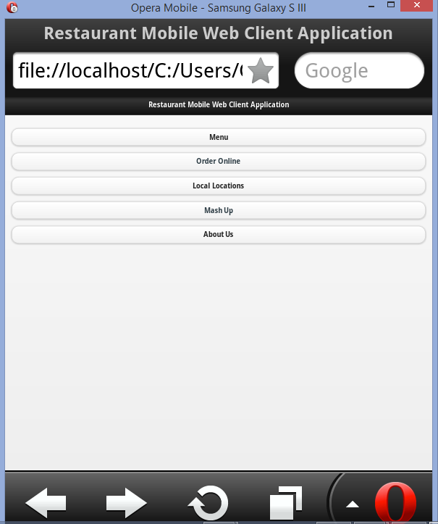

Order online involves the local data storage where customers can add the items for carry out in the textbox and review the items added with the review items button. ustomers can add the items for the carry out.

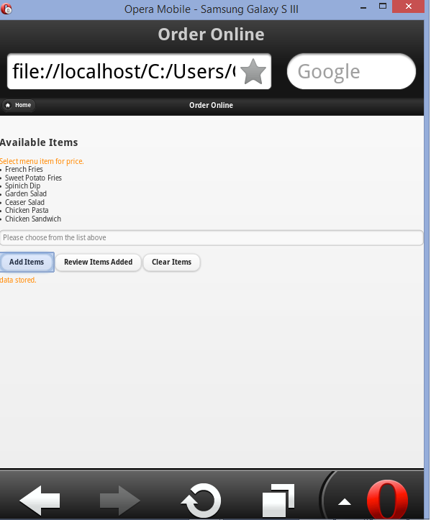

Review the items added to the local database with the review the items button.

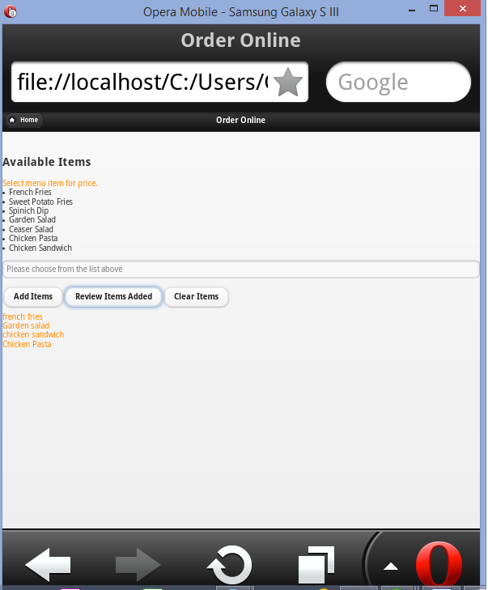

The items stored in the database can be cleared with Clear Items button.

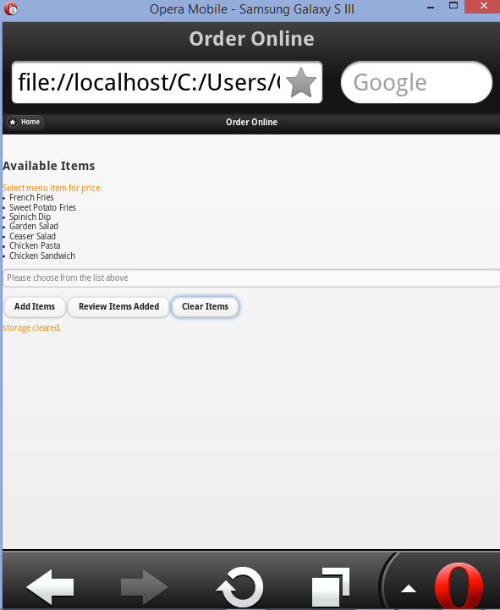

Mashup Application

Mashup application with Google weather Api and Yahoo Finance chart. The chart displays the stock values of the Restaurant for that day and Google Weather Api that includes map of the surrounding areas of the Restaurant along with the temperatures.

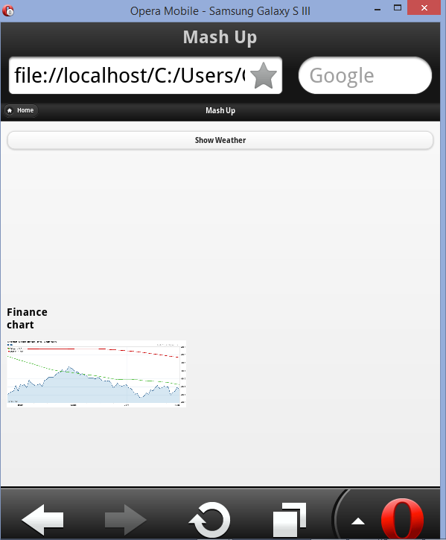

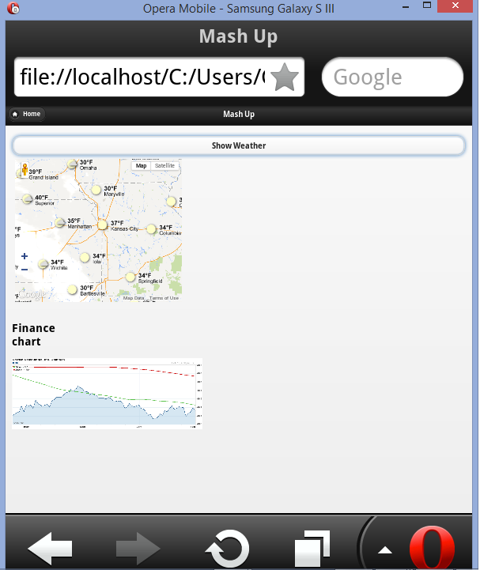

 Calling REST Web Services

Upon clicking the Menu items below the application makes a call to the REST webservice and passes the selected menu item name as the identifier. The service then returns the price for the requested item. If the requested item is invalid then returns zero for price. The selected Item and price is displayed on the screen.

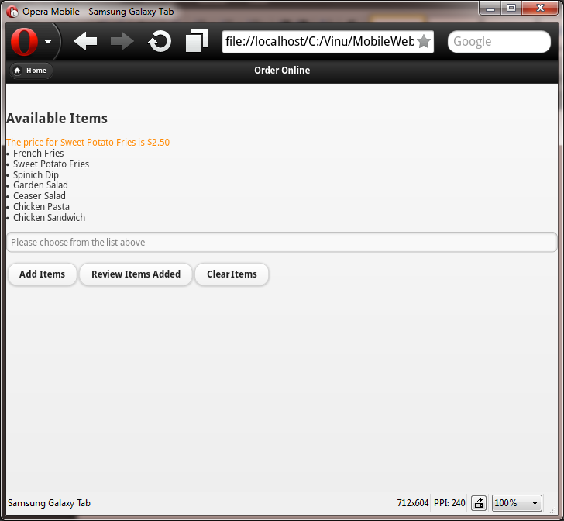

Below screenshot demonstrates that the request was sent to REST web service and response for specified input.

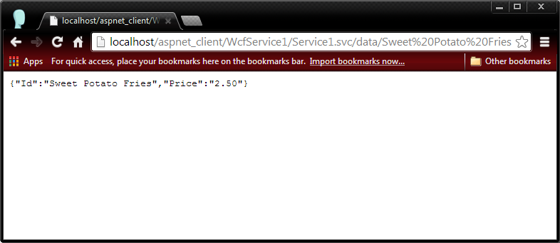

Another set of screenshots for web service request for different input parameter.

